Truncated Hexagonal Prism

Definition
# Source: AI Source: Provided by: [Data Path: Persons Table -> ID Column: 1, Name_En Column: Motasem Essam] -> From: [ChatGPT] on [7/25/2026]
A Truncated Hexagonal Prism is a solid derived from a hexagonal prism by cutting off one or more portions using planes.
The cuts create new faces and modify the original faces of the prism. Its final geometric structure depends on the number, position, and orientation of the cutting planes.
There is no single fixed face arrangement or set of dimensions for every truncated hexagonal prism.
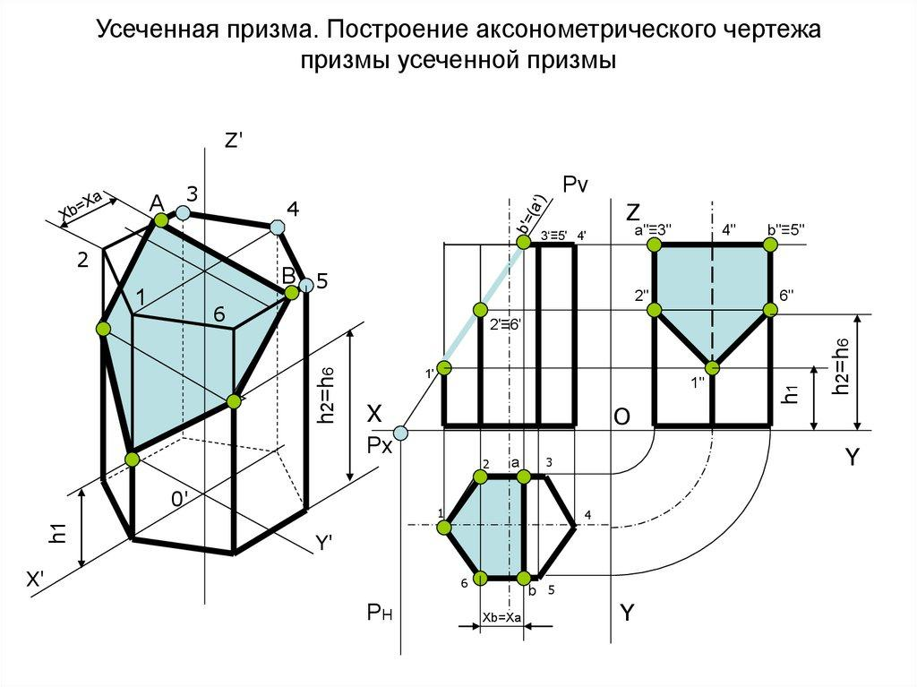

Geometric Structure
# Source: AI Source: Provided by: [Data Path: Persons Table -> ID Column: 1, Name_En Column: Motasem Essam] -> From: [ChatGPT] on [7/25/2026]
A regular hexagonal prism consists of:
- 2 Hexagonal Bases — top and bottom.
- 6 Rectangular Lateral Faces — connecting the two bases.
- 12 Vertices.
- 18 Edges.
- 8 Faces in total.
When the prism is truncated, cutting planes remove portions of the original solid and create new polygonal faces.
Common truncation arrangements include:
- Single Inclined Cut: One inclined plane cuts through the prism.
- Parallel Cuts: Two or more parallel planes remove portions of the prism.
- Vertex Truncation: One or more vertices are cut off.
- Multiple Truncations: Several portions are removed from different locations.

Face Composition
# Source: AI Source: Provided by: [Data Path: Persons Table -> ID Column: 1, Name_En Column: Motasem Essam] -> From: [ChatGPT] on [7/25/2026]
The face composition depends on the truncation method.
For example, when a single inclined plane intersects all six lateral faces without intersecting either original base, the resulting portion can have:
- 1 Hexagonal Base — one original base.
- 6 Modified Lateral Faces — formed from the original rectangular faces.
- 1 Hexagonal Cutting Face — created by the inclined plane.
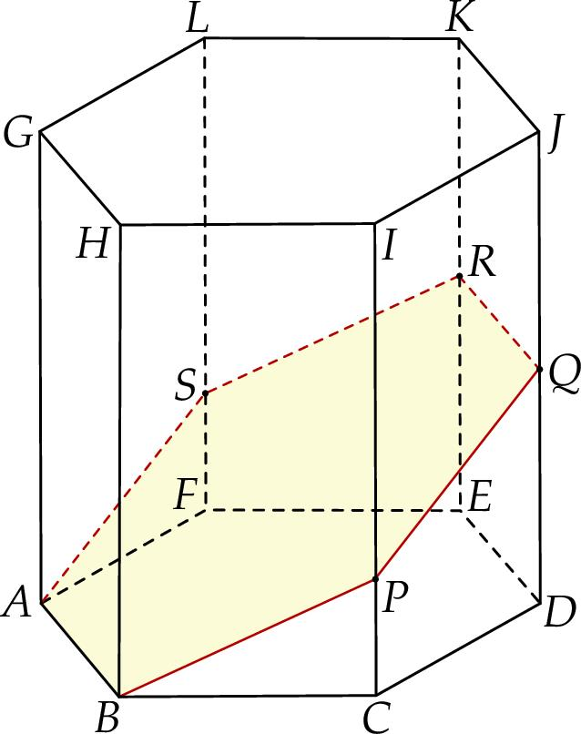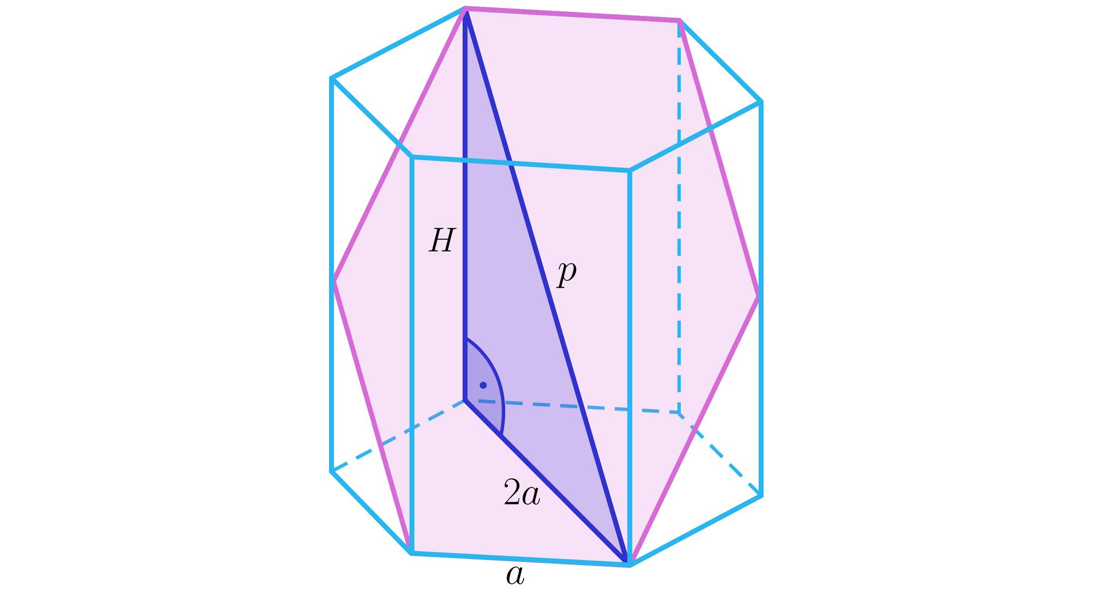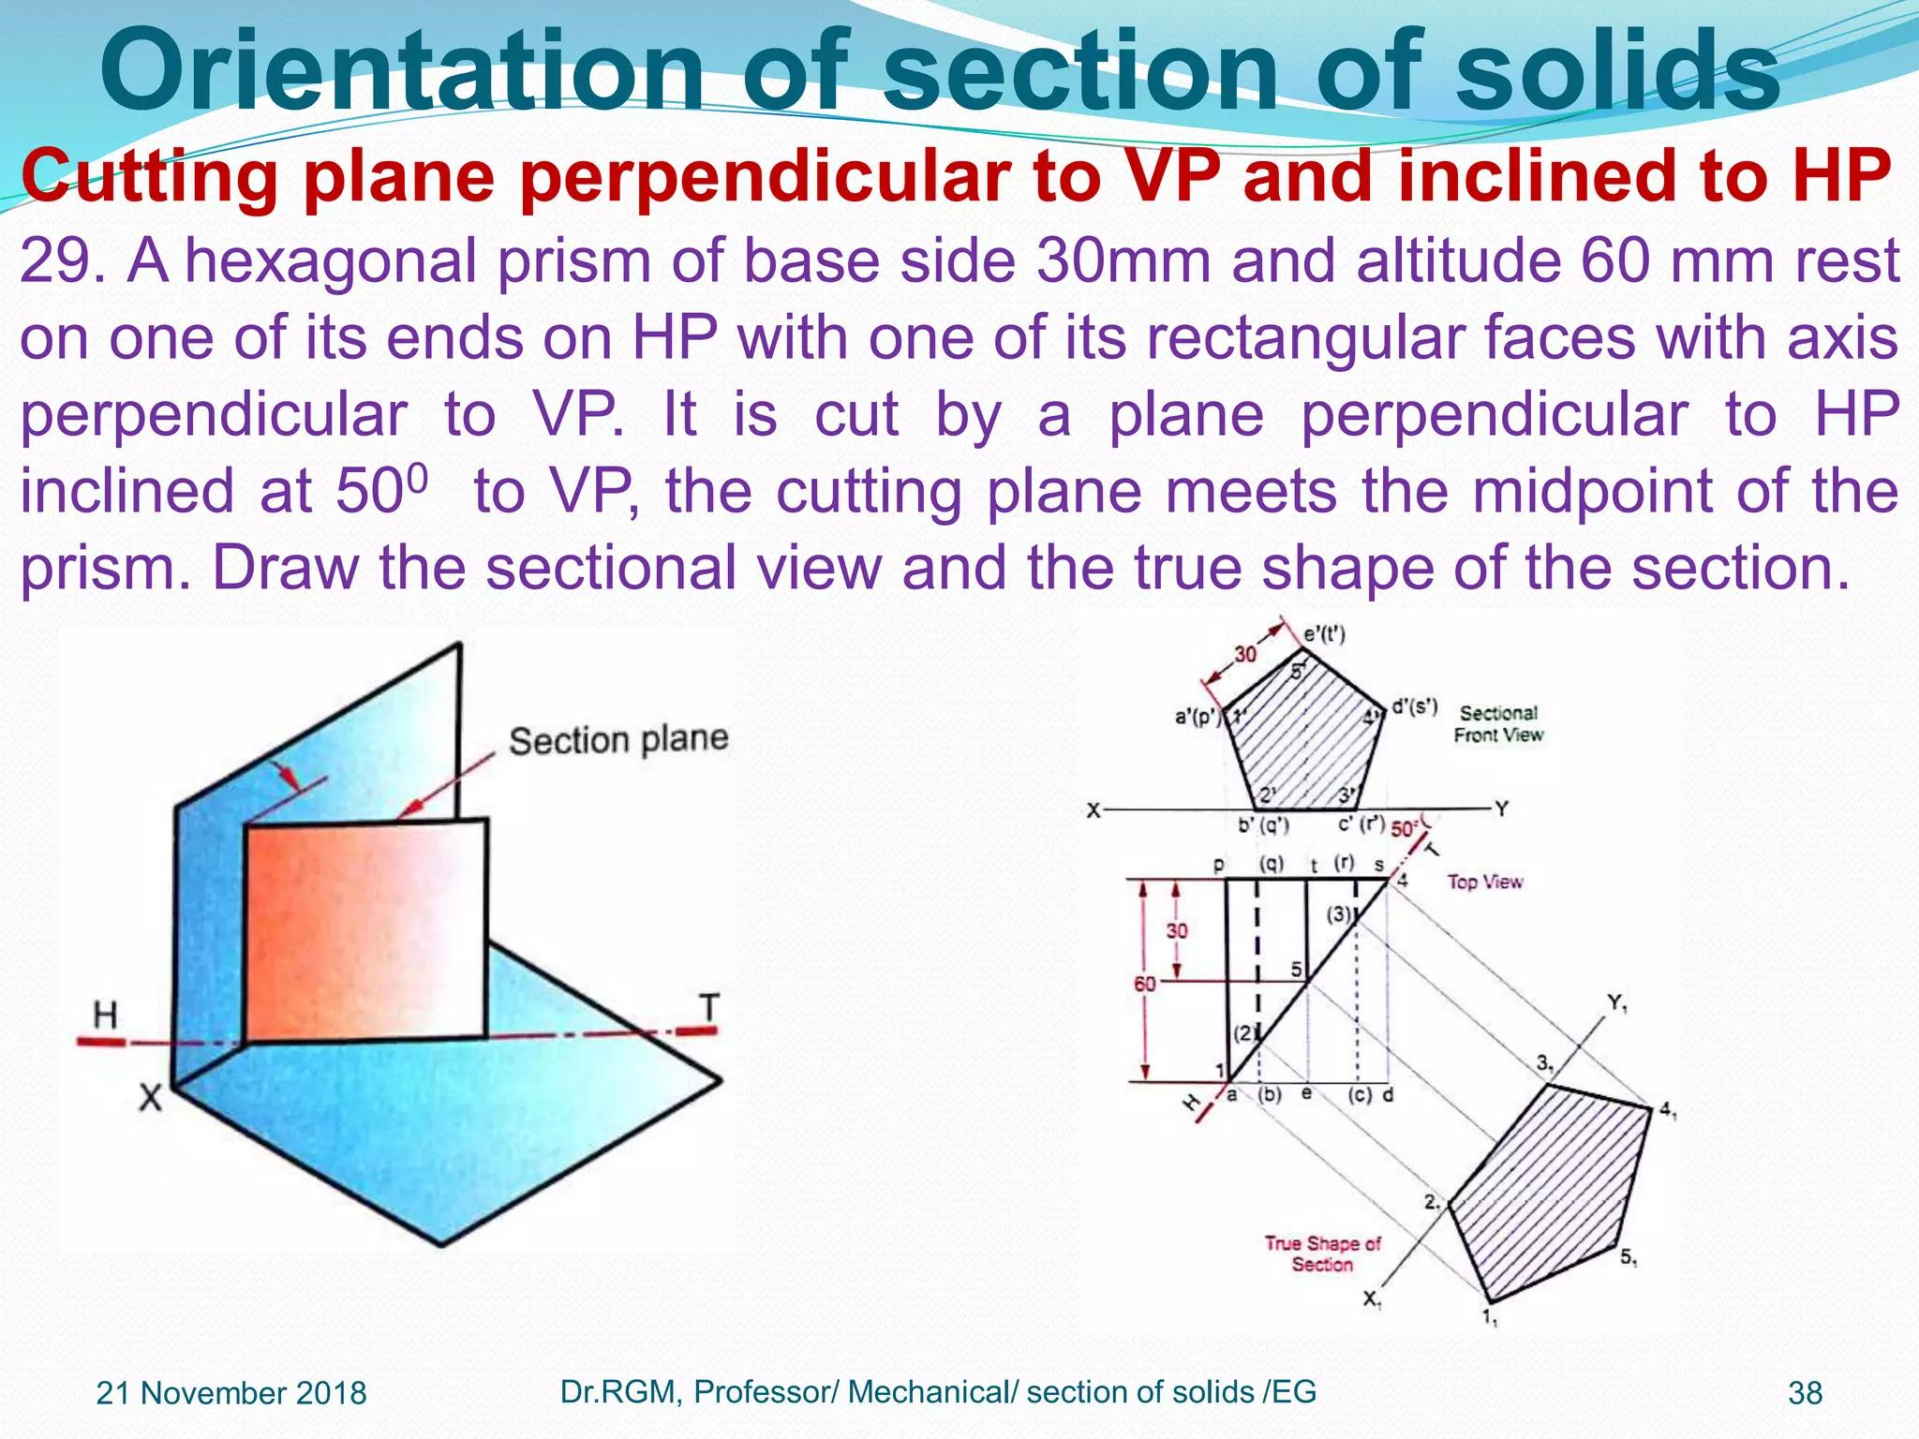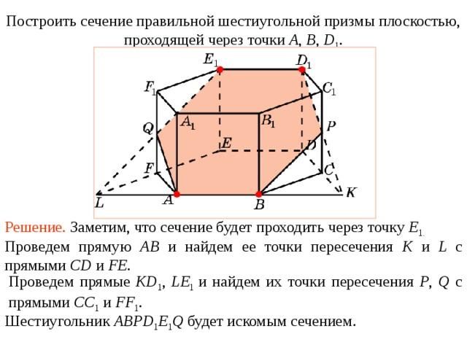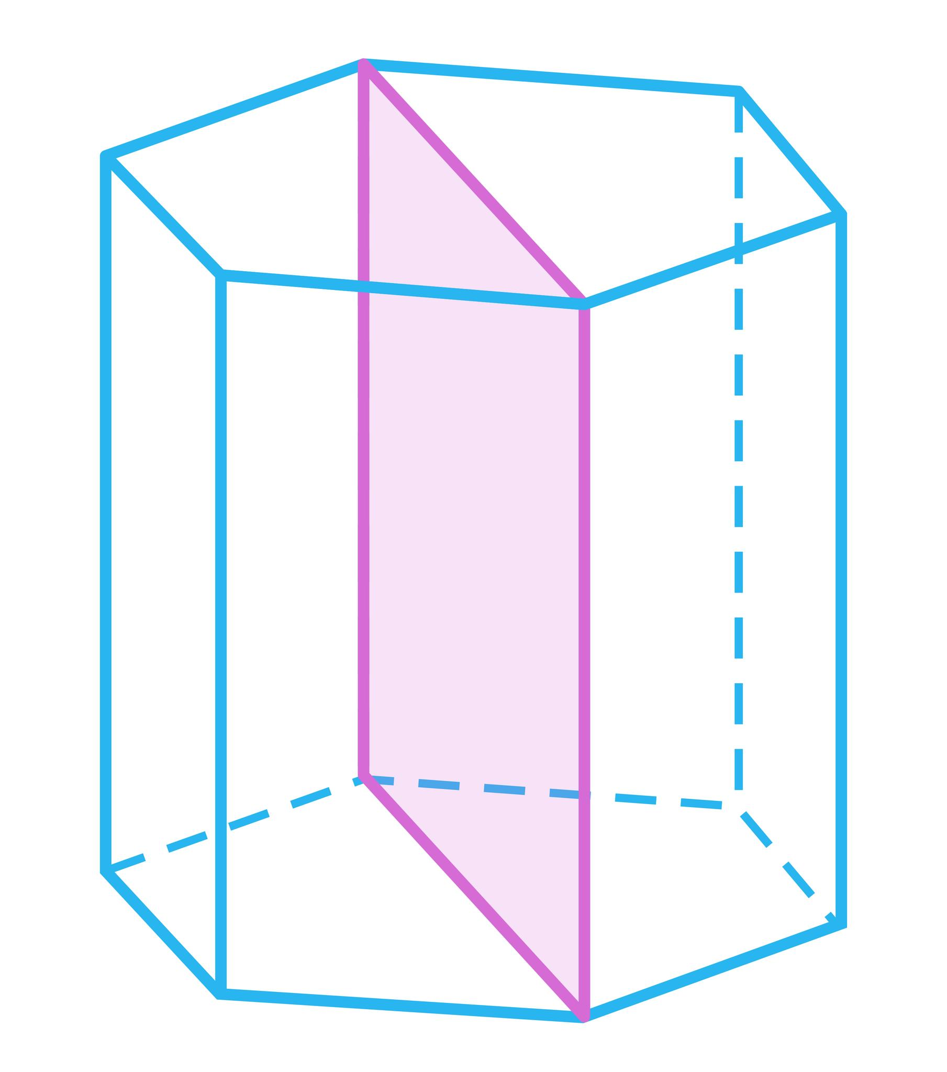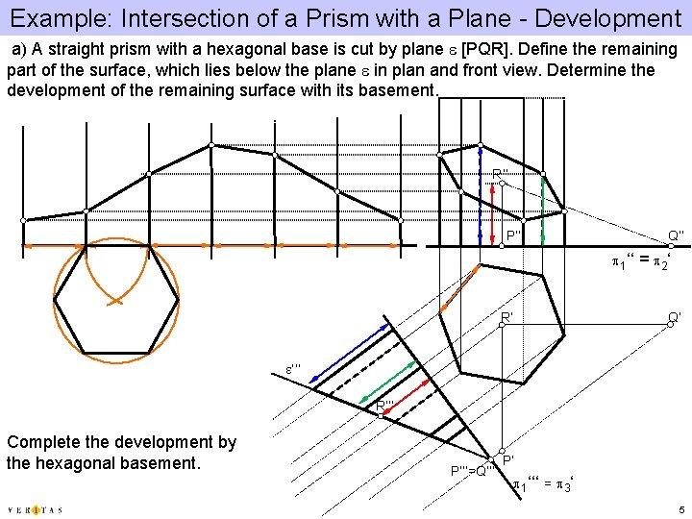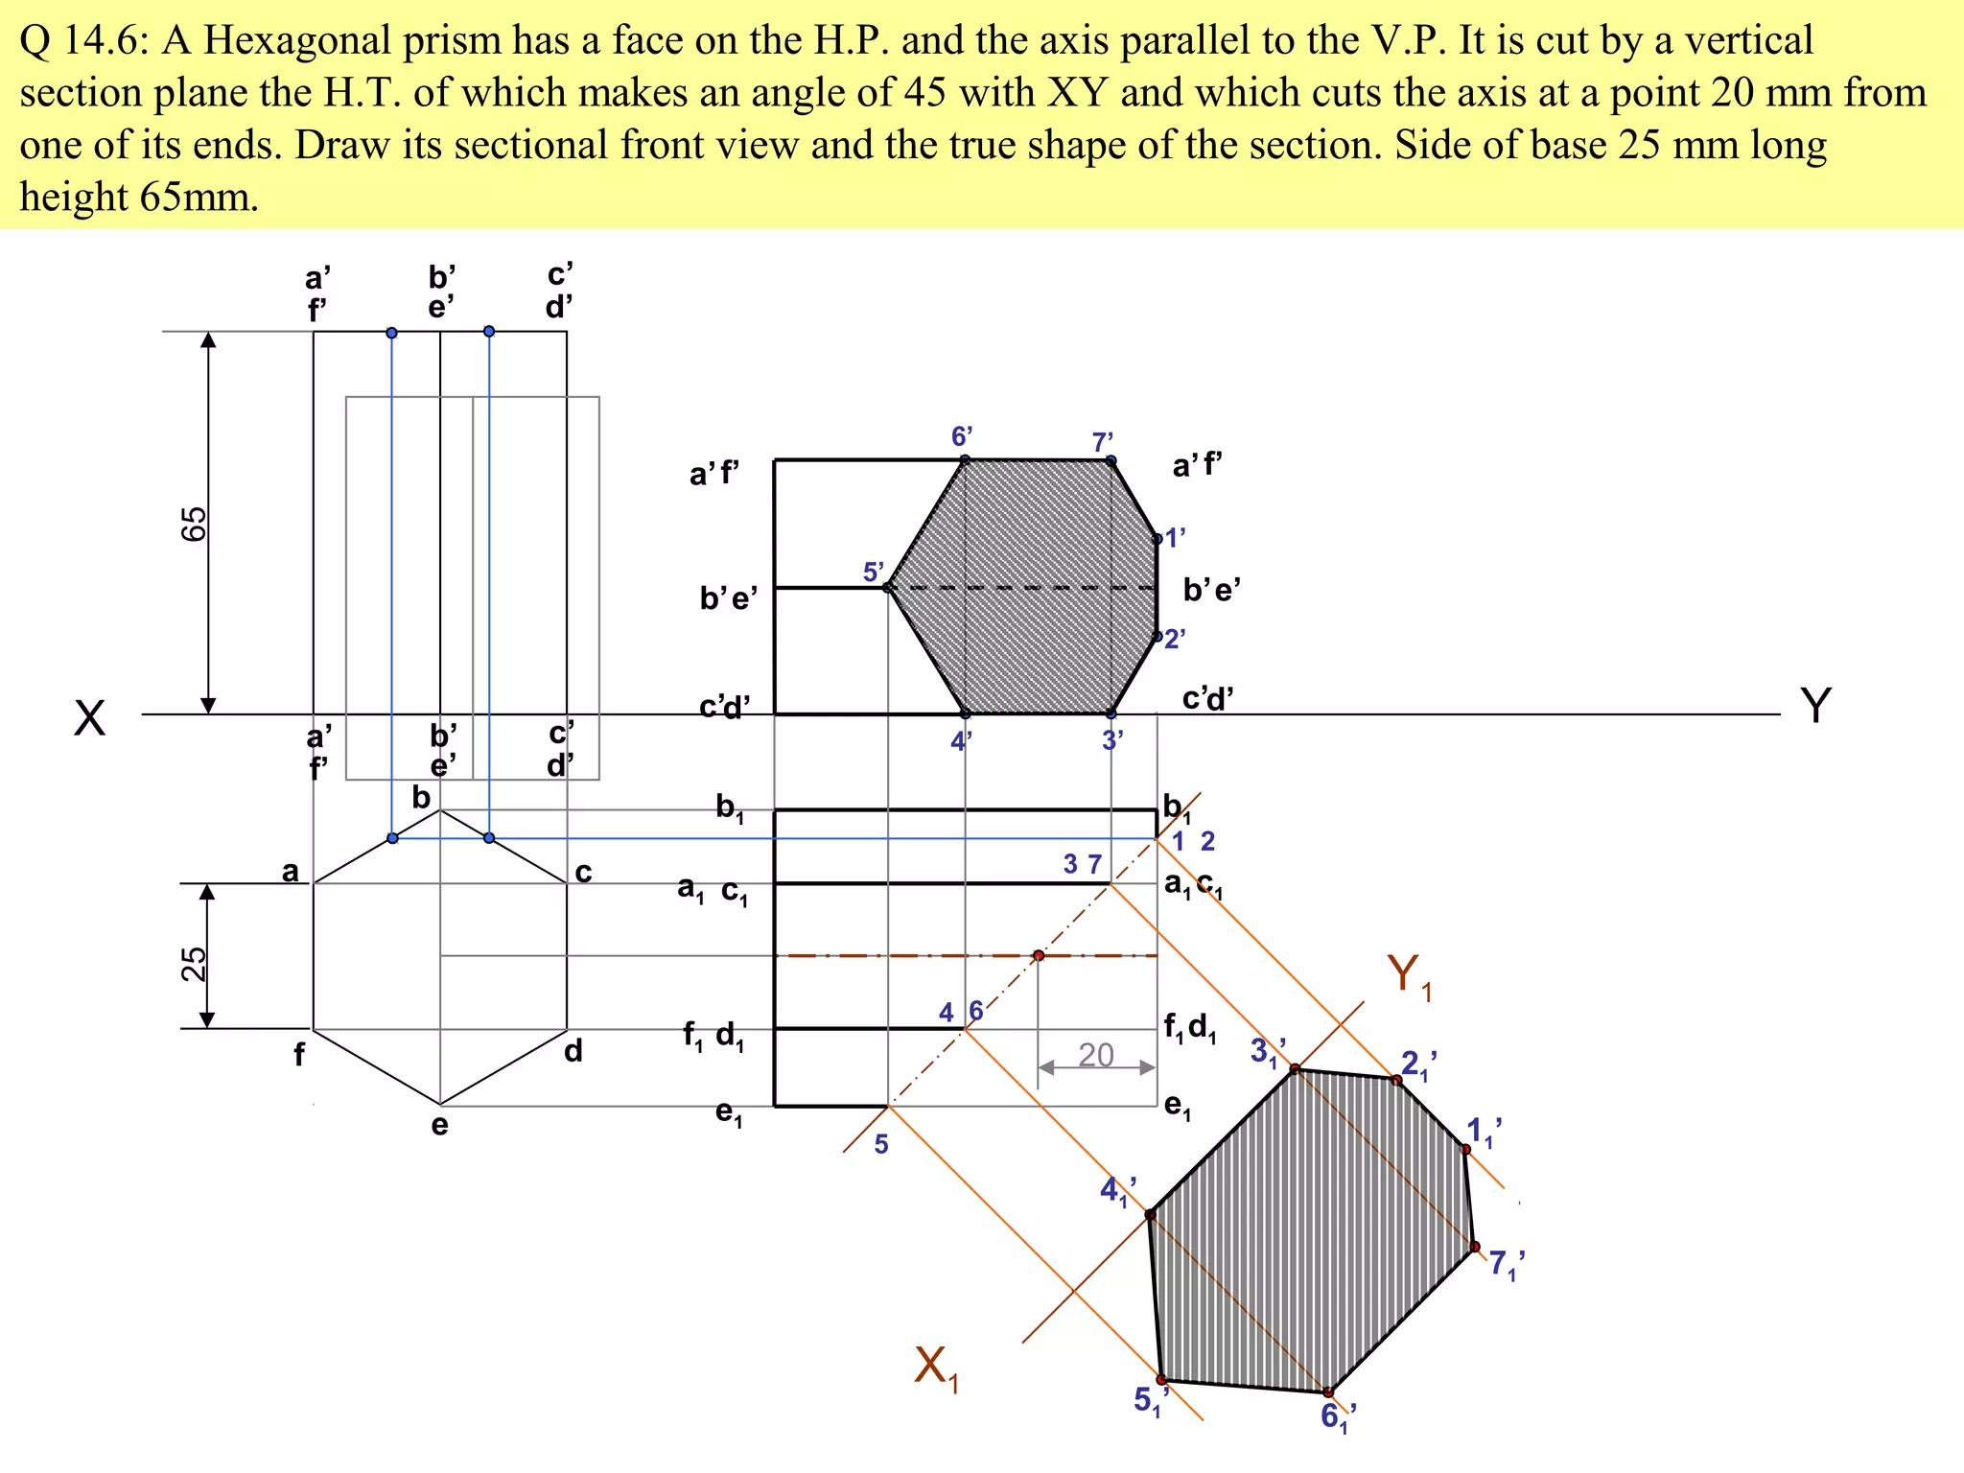
The modified lateral faces may be quadrilaterals, depending on the cutting plane.

Mathematical Properties
# Source: AI Source: Provided by: [Data Path: Persons Table -> ID Column: 1, Name_En Column: Motasem Essam] -> From: [ChatGPT] on [7/25/2026]
Original Regular Hexagonal Prism
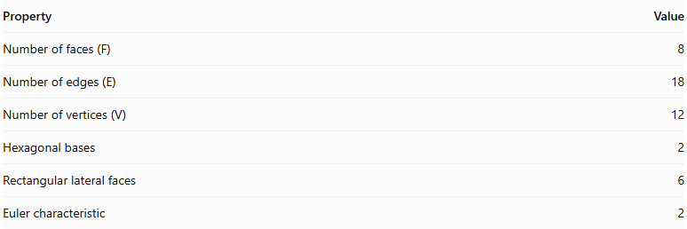
Property | Value
Number of faces (F) | 8
Number of edges (E) | 18
Number of vertices (V) | 12
Hexagonal bases | 2
Rectangular lateral faces | 6
Euler characteristic | 2
For a truncated version:
The number of faces, edges, and vertices depends on the truncation arrangement.
Euler's Formula
$$V-E+F=2$$
This formula applies to convex, closed polyhedra, including truncated hexagonal prisms.

Constructing a Truncated Hexagonal Prism

Geometric Instruments
# Source: AI Source: Provided by: [Data Path: Persons Table -> ID Column: 1, Name_En Column: Motasem Essam] -> From: [ChatGPT] on [7/25/2026]

- Ruler / Straightedge: Drawing straight edges, lateral edges, and projection lines.
- Compass: Constructing a regular hexagonal base and transferring equal lengths.
- Protractor: Measuring the inclination of the cutting plane.
- Set Squares: Drawing perpendicular, vertical, and parallel construction lines.
- Pencil: Drawing outlines and construction lines.
- Eraser: Removing unnecessary construction marks after completion.

Instrument-Based Construction Procedures

Method 1: Construction Using an Oblique Cutting Plane
# Source: AI Source: Provided by: [Data Path: Persons Table -> ID Column: 1, Name_En Column: Motasem Essam] -> From: [ChatGPT] on [7/25/2026]
- Draw a regular hexagon $ABCDEF$ using a compass and straightedge.
- Construct six lateral edges perpendicular to the hexagonal base.
- Connect their upper endpoints to form the upper hexagonal face of the complete prism.
- Mark six intersection points $A',B',C',D',E',F'$ on the lateral edges.
- Position the points at different heights according to the required cutting-plane inclination.
- Join the six points consecutively to form the hexagonal cutting section.
- Remove the upper portion of the prism conceptually, retaining the lower truncated portion.
- Darken the visible edges and use dashed lines for hidden edges.

Method 2: Construction Using Orthographic Views
# Source: AI Source: Provided by: [Data Path: Persons Table -> ID Column: 1, Name_En Column: Motasem Essam] -> From: [ChatGPT] on [7/25/2026]
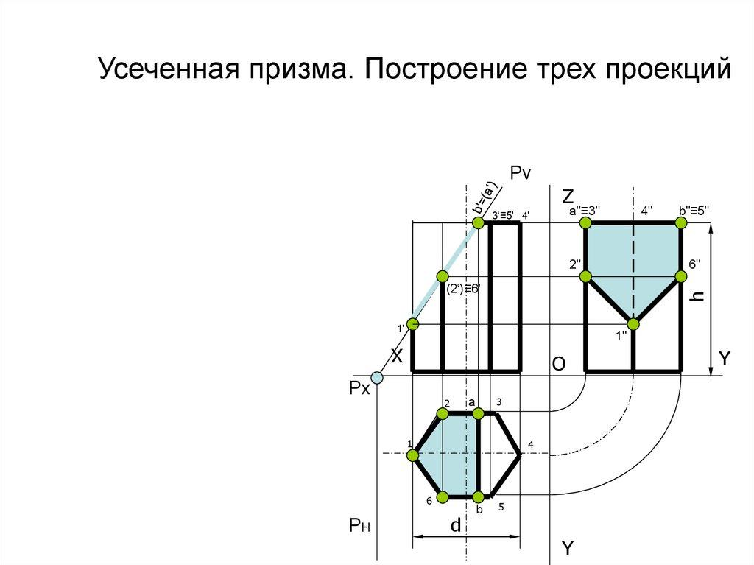
- Draw the hexagonal base in the top view.
- Project the six base vertices into the front elevation.
- Construct the lateral edges and establish the prism height.
- Draw the cutting plane in the appropriate elevation.
- Mark the six intersections between the cutting plane and the lateral edges.
- Project these intersection points into the corresponding views.
- Use an auxiliary view when necessary to obtain the true shape of the inclined cutting section.
- Complete the isometric view using the orthographic projections.

Method 3: Construction Using Surface Development
# Source: AI Source: Provided by: [Data Path: Persons Table -> ID Column: 1, Name_En Column: Motasem Essam] -> From: [ChatGPT] on [7/25/2026]
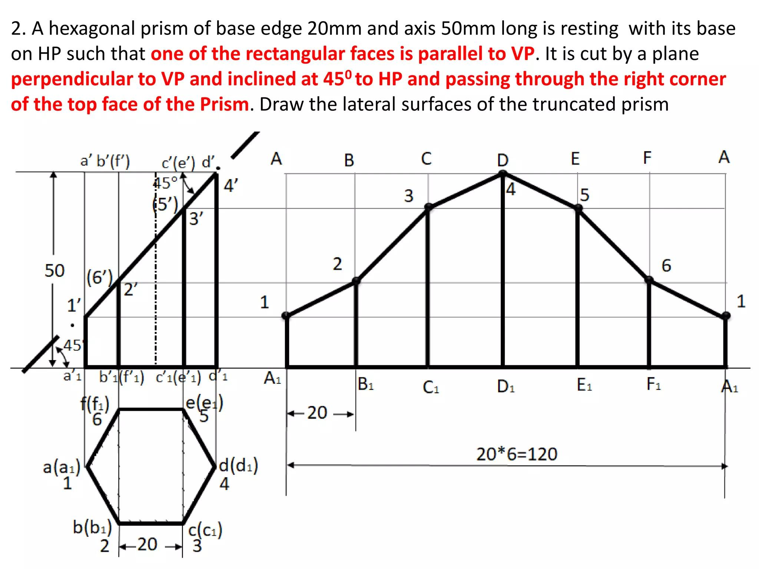
- Draw the projections of the complete hexagonal prism.
- Draw the cutting plane and identify its intersections with the six lateral edges.
- Draw the development baseline and mark off the six equal base sides consecutively.
- Erect perpendicular construction lines at the division points to represent the lateral edges.
- Transfer the cutting heights from the orthographic view onto the corresponding developed edges.
- Join the transferred points consecutively to form the developed cutting boundary.
- Attach the original hexagonal base to the developed lateral surface.
- Check corresponding edge lengths and distinguish cut edges from fold lines.
This method follows the engineering-drawing procedure for developing a truncated hexagonal prism by transferring the cutting intersections from orthographic views to the unfolded lateral faces.

Key Points
# Source: AI Source: Provided by: [Data Path: Persons Table -> ID Column: 1, Name_En Column: Motasem Essam] -> From: [ChatGPT] on [7/25/2026]
- It originates from a hexagonal prism.
- It belongs to the family of truncated prisms.
- Cutting planes create new polygonal faces.
- The resulting faces may include triangles, quadrilaterals, hexagons, and other polygons.
- A single inclined cut and vertex truncation produce different geometric structures.
- Its mathematical properties depend on the cutting method.

Conclusion
# Source: AI Source: Provided by: [Data Path: Persons Table -> ID Column: 1, Name_En Column: Motasem Essam] -> From: [ChatGPT] on [7/25/2026]
The Truncated Hexagonal Prism is a modified hexagonal prism formed by removing one or more portions using cutting planes. Its final shape, face composition, number of edges, and number of vertices depend on the truncation method.

